**$PAJAMAS: The Coin That Brought the YouTube Legend into Crypto**

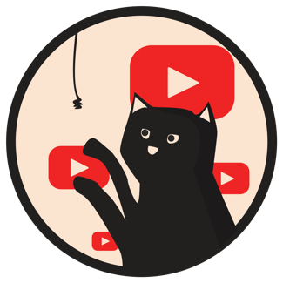

**Introduction**

Out of the thousands of meme coins that emerge every day, one stands out with a story that tugs at the heartstrings of internet historians and cat lovers alike. $PAJAMAS isn’t just another meme coin; it’s a tribute to Pajamas, the first cat ever recorded on YouTube by none other than Steve Chen, Co-Founder of YouTube. This story begins on May 22nd, 2004, with a video titled “Pajamas and Nick Drake,” marking a humble yet historic moment in the digital world. Fast forward 20 years, and the spirit of Pajamas lives on through $PAJAMAS, a coin that has found its ninth life in the hands of a passionate community.

**The Revival of $PAJAMAS**

Initially launched by a developer who later stepped away, $PAJAMAS found its true calling when the community realized its potential, and the project became community-run. They recognized that this was not just about a meme; it was about preserving a piece of internet history and fostering a new kind of connection in the digital age. The turning point came when the community’s enthusiasm caught Steve Chen’s attention, leading to an unforeseen full circle moment. With Steve’s curiosity piqued, knowing almost nothing about crypto and how it works, he became curious and wanted to be part of this, guided by the community that cherished his cat’s legacy. Today, Steve is not just a bystander but an integral part of the $PAJAMAS narrative, working alongside the community to shape its future.

**Why $PAJAMAS Stands Apart**

While the crypto space is no stranger to cat-themed tokens, $PAJAMAS distinguishes itself through its authentic connection to a universally recognized moment in internet culture. It represents the first step into the world of digital video sharing, a reminder of how far we’ve come and the unexplored potential ahead. $PAJAMAS transcends its meme coin status by embodying the spirit of community, curiosity, and inclusivity.

**Our Vision**

$PAJAMAS’s vision is twofold: Firstly, it aims to be more than just a cryptocurrency; it’s a gateway for the crypto-curious, much like Steve, who once stood at the threshold, uncertain yet intrigued. We’re dedicated to demystifying the world of crypto for “normies,” making it accessible and engaging for everyone. Our mission extends beyond market value, focusing on building a supportive community where learning, sharing, and growing together is celebrated.

Secondly, as part of our Social Responsibility, we are committed to revolutionizing feline welfare through our Pajamas Foundation. We aim to create a brighter future for cats globally, where every feline receives the care they deserve. You can read more about this at www.pajamas.foundation.

**Join the $PAJAMAS Journey**

Whether you’re a seasoned crypto enthusiast, a newcomer eager to learn, or simply someone who appreciates the charm of a historic internet cat, $PAJAMAS welcomes you. We invite you to become a part of writing the next chapter in the $PAJAMAS story. Together, we’re not just investing in a coin; we’re investing in the power of community and the enduring legacy of a cat named Pajamas, who unknowingly set the stage for a global platform that connects millions.

**Call to Action**

Become a part of the $PAJAMAS story. Connect with us, learn about crypto, and help us grow a community where everyone feels at home. Let’s show the world that crypto is about more than just transactions; it's about history, community, and shared experiences.

Purrr with <3

Pajamas.Cat